1. 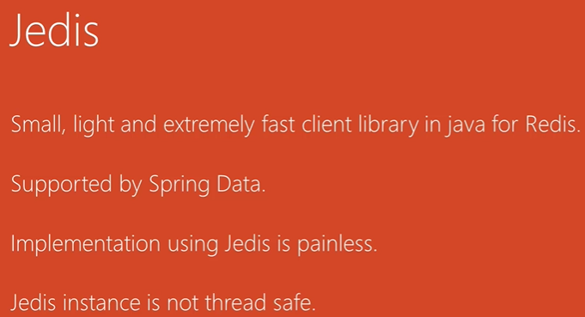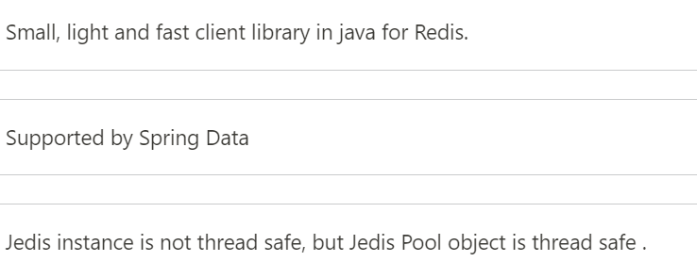  
   Jedis is **not thread-safe**. However, you can achieve thread safety using general pool.   
   By the way, Redis itself is **single threaded**. Single threaded program can provide concurrency at the I/O level by using the multiplexing mechanism and the event loop which is basically what Redis does.
2. Using the same Jedis instance from multiple threads at the same time will **result in socket connection errors**.  
   If we want to avoid that we need to use the Jedis instance in thread safe way by using **Jedis Pool**.  
   Jedis Pool object is thread-safe can be used in multiple threads at the same time.
3. **Benefits of Jedis Pool**:
   1. Each time we send DB request to make a new connection.
   2. Pool keeps a no of connections opened based on the pool configuration.   
      When request comes, we take connection from the pool when done with the request, we send back the connection to the pool.
4. 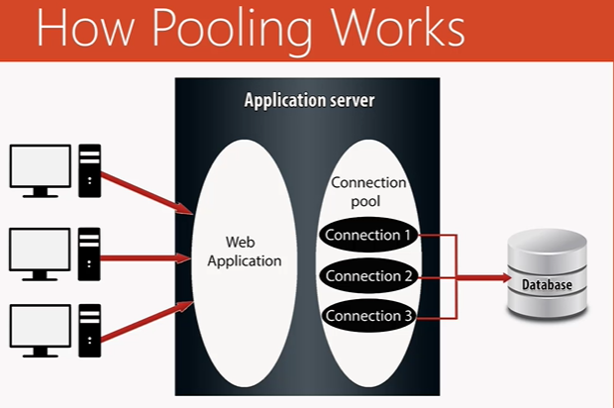  
   **NOTE**: When a request comes and all connections are busy, a new connection can be created based on the configuration you provide.